**WEEK #2**

**TASK #3**

**What is SQL?**

SQL stand for “Structured query language”.

It is a standard language for accessing and manipulating databases.

It can execute queries against a database. Its used to create new database , tables into that database ,stored procedures in database and also set permissions on tables, procedures and views.

In simple words it’s a computer language which is designed for management of data in relational database such as MYSQL,MS Access,SQL server, Oracle, Sybase, Informix, PostgreSQL etc.

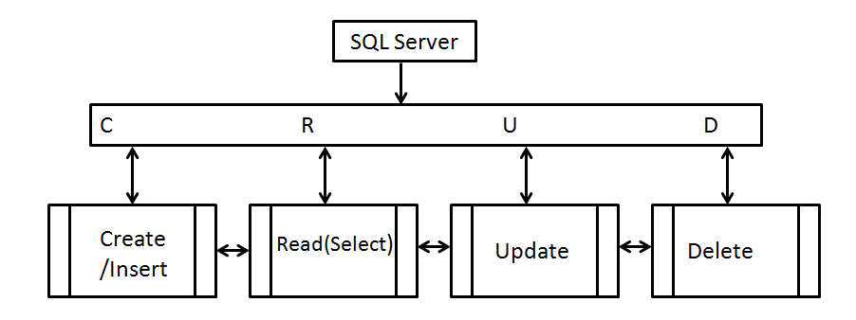

**What is DDL?**

DDL stand for “Data Definition language”.

It is a subset of SQL for describing data and its relationship in a database. Its used to create and modify the structure of objects in a database by using predefined commands and specific syntax. Thses database objects include views, schemas, sequences, locations, aliases, tables, indexes,etc.

DDL commands are ALTER, COMMENT, CREATE, DESCRIBE, DROP, SHOW and USE.

**What is DML?**

DDL stand for “Data Manipulation language”.

DML statement access and manipulate data in existing schema.It is explicitly used to make changes in a database such as CRUD operations CRUD( Create, Read,Update, Delete) operation in a database by using commands INSERT,SELECT,UPDATE and DELETE commands.

**What is DQL?**

DDL stand for “Data Query language”.

DQL is a compnent of SQL that allows getting data from database and imposing order upon it. It is used for performing queries on the data within schema objects . the purpose of these commands are to get some schema relation based on the query passed to it . Its include SELECT statement and its used to retrieve data from the database.

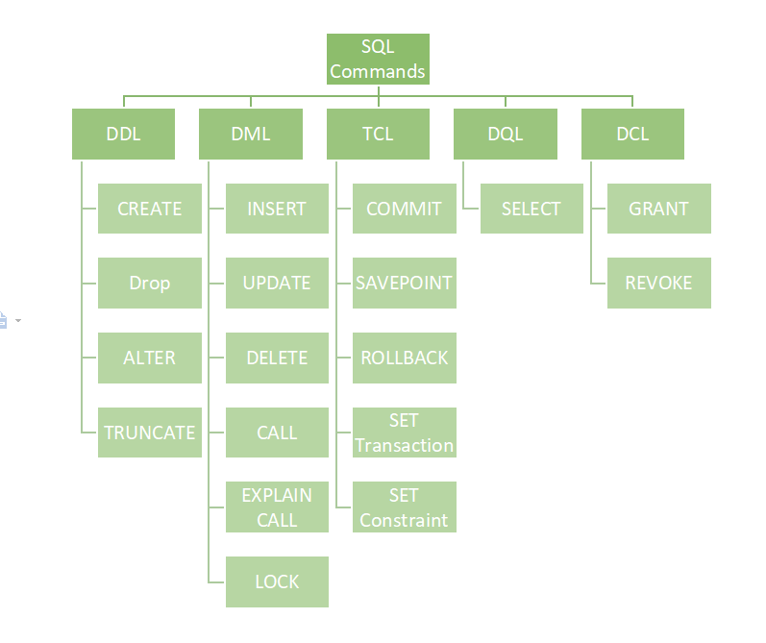

**Task #4**

